Exam 3 Review

- The median annual income for women with x years of education can be modeled by the function $W\left(x\right)=-1.2x^{3}+367x^{2}-4900x+26,561.$
  - Find $W\left(16\right)$
  - Find $W^{'}\left(x\right)$
  - Find $W^{'}\left(16\right)$and interpret the meaning. Include the correct units.

- The monthly sales of Bluetooth headphones can be modeled by $S\left(x\right)=30x-\frac{1}{2}x^{2}$ where x represents the number of months since the headphones were initially sold and $S(x)$ represents the number of units sold in hundreds.
  - Find $S\left(6\right)$
  - Find $S^{'}\left(x\right)$
  - Find $S^{'}\left(6\right)$and interpret the meaning. Include the correct units.

- The projected sales of e-books, in millions, can be modeled by the function $S\left(x\right)=-17x^{3}+200x^{2}-113x+44$, where x is the number of years since 2000.
  - Find $S\left(10\right)$
  - Find $S^{'}\left(x\right)$
  - Find $S^{'}\left(10\right)$and interpret the meaning. Include the correct units.

- The average height (in inches) for girls ages 1 to 20 can be modeled by the equation $G\left(x\right)=-0.0002x^{4}+0.006x^{3}-0.14x^{2}+3.7x+26$, where x is the age in years.
  - Find $G\left(16\right)$
  - Find $G^{'}\left(x\right)$
  - Find $G^{'}\left(16\right)$and interpret the meaning. Include the correct units.

- The median annual income for men with x years of education can be modeled by the function $M\left(x\right)=0.6x^{3}+285x^{2}-2256x+15,112.$
  - Find the average rate of change in the median annual income for men between 10 years of education and 18 years of education. Make sure to include correct units.
  - Find $M'\left(x\right)$
  - Find $M^{'}\left(14\right)$and interpret the meaning. Include the correct units.

- The average height (in inches) for boys ages 1 to 20 can be modeled by the equation $B\left(x\right)=-0.001x^{4}+0.04x^{3}-0.56x^{2}+5.5x+25$, where x is the age in years.
  - Find the average rate of change in a boys height between 12 years and 18 years. Make sure to include correct units.
  - Find $B'\left(t\right)$
  - Find $B^{'}\left(10\right)$and interpret the meaning. Include the correct units.

- Evaluate marginal cost and marginal revenue at a production level of 5 items increasing to 6 items. Interpret the meaning of the marginal cost and revenue. Should the company increase production?

$C\left(x\right)=3x^{2}-5x+40$, $R\left(x\right)=-8x^{2}+10x+30$

- Evaluate marginal cost and marginal revenue at a production level of 5 items increasing to 6 items. Interpret the meaning of the marginal cost and revenue. Should the company increase production?

$C\left(x\right)=0.05x^{2}+2x+80$, $R\left(x\right)=-{2x}^{2}+100x$

- During the course of an illness, a patient’s temperature (in degrees Fahrenheit) x hours after the start of the illness is given by $T\left(x\right)=\frac{98.6x^{2}+530}{x^{2}+5}$
  - Find $T(3)$
  - Find $T^{'}\left(x\right)$
  - Find $T'(3)$ and interpret the meaning. Use correct units.

- The percent of concentration of a drug in the bloodstream x hours after the drug is administered is given by $K\left(x\right)=\frac{400x^{2}+100}{3x^{2}+27}$.
  - Find $K(2)$
  - Find $K^{'}\left(x\right)$
  - Find $K'(2)$ and interpret the meaning. Use correct units.

- The temperature of a certain patient (in degrees Fahrenheit) t hours after the onset of an infection can be approximated by $P\left(t\right)=98.6+te^{-0.2t}$.
  - Find $P(12)$
  - Find $P'(t)$
  - Find $P'(12)$ and interpret the meaning. Include correct units.

- Sales at a fireworks outlet (in thousands of dollars) on day x can be approximated by $S\left(x\right)=1+5xe^{-0.3x}$, where x = 1 corresponds to July 1.
  - Find $S(2)$
  - Find $S'(x)$
  - Find $S'(2)$ and interpret the meaning. Include correct units.

- A business manager estimates that when x thousand people are employed at her firm, the profit will be $P\left(x\right)$ million dollars, where $P\left(x\right)=\ln\left(x\right)+1.3x+5$
  - Find $P(2)$
  - Find $P^{'}\left(x\right)$
  - Find $P'(2)$ and interpret the meaning. Include correct units.

- A model for consumers’ response to advertising is given by $N\left(x\right)=2000+58.5x^{2}+lnx$where $N(x)$ is the number of units sold and x is the amount spent on advertising, in thousands of dollars.
  - Find $N(10)$
  - Find $N'(x)$
  - Find $N'(10)$ and interpret the meaning. Include correct units.

- The average fuel (in gallons) consumed by individual vehicles in the United States from 1960 to 2000 is shown in the graph below.
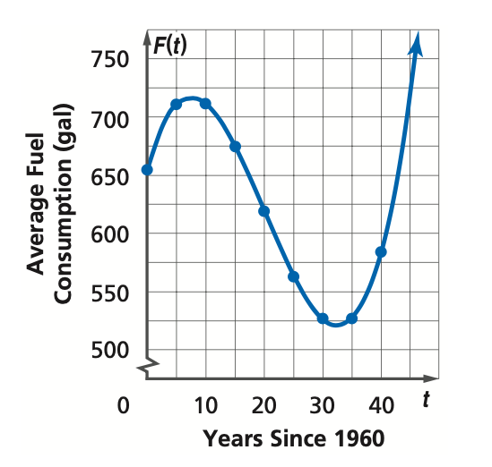
Find the average rate of change in the fuel consumption of individual vehicles in the United States between 1980 and 2000. Make sure to include correct units.

For the following problems:
- Find the first derivative
- Find the critical values
- Find the second derivative
- Evaluate the second derivative for all critical values. Find the coordinates of the maximums/minimums.

- $f\left(x\right)=2x^{3}+3x^{2}-12x$ | - $f\left(x\right)=-x^{3}+6x^{2}-9x-1$
- $f\left(x\right)={-x}^{3}+6x^{2}-15$ | - $f\left(x\right)=x^{3}-3x^{2}+10$
- $f\left(x\right)=x^{2}+6x+10$ | - $f\left(x\right)=-2x^{2}+4x+3$

